OOP EXPERIMENT-1

NAME-ANMOL SAP-590011794 BATCH-20
DATE-1 FEB 2026
SUBMITTED TO- PROF. Kalluri Shareef Babu

Topics to be covered:class creation,running,compiling,varable type declaration,if else,operators,printing statements as outputs

EX 1A
Write a Java program to print Name, Roll Number and Branch.
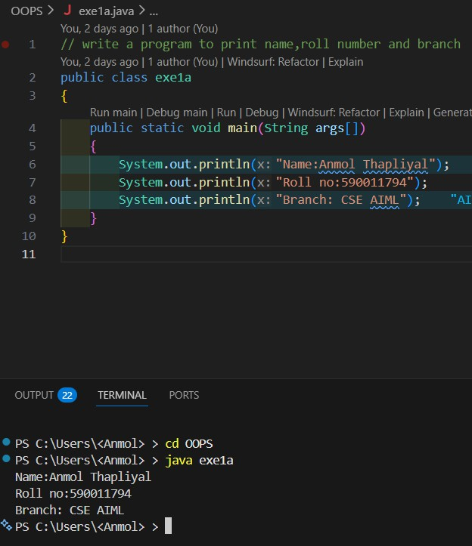
Observation:
creates a class named exe1a and prints the name, roll number and branch of the student.

EX 1B
Write a Java program to declare two integers and print their sum.

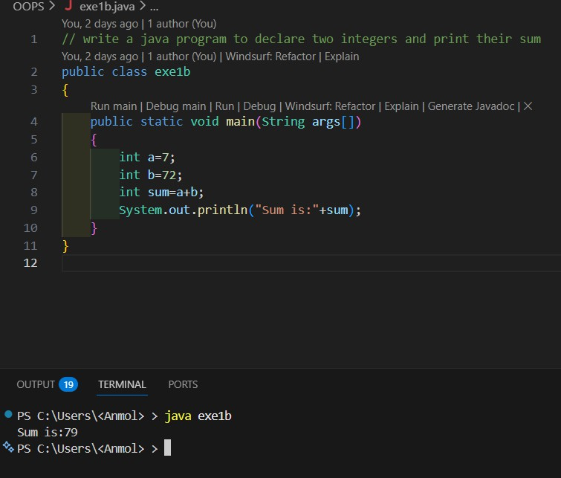

Observation: creates a class named exe1b and prints the sum of two integers using main method and int data type variables a and b

EX 1C
Write a Java program to calculate the area of a rectangle.

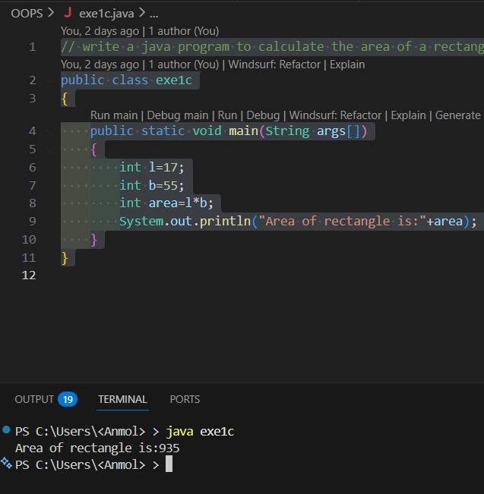

Observation:creates a class named exe1c and prints the area of a rectangle using main method and int data type variables l and b for length and breadth respectively

EX 1D
Write a Java program to calculate Simple Interest.

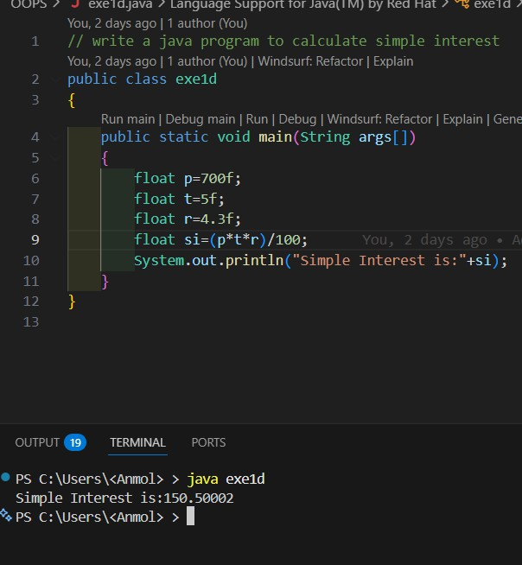
Observation: creates a class named exe1d and prints the simple interest using main method and float data type variables p, t and r for principal, time and rate respectively and si for simple interest variable is created to store the calculated simple interest value.

EX 1E
Write a Java program to swap two numbers using a temporary variable.

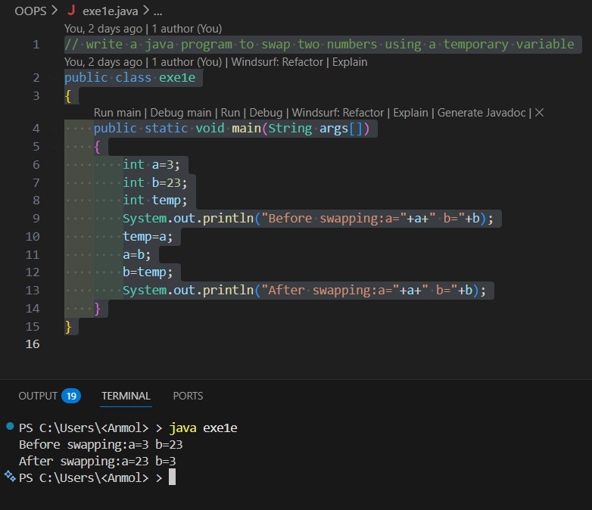
Observation: creates a class named exe1e and swaps two numbers using a temporary variable and prints the values before and after swapping using main method and int data type variables a and b for the two numbers and temp for temporary variable.

EX 1F
Write a Java program to swap two numbers without using a temporary variable.

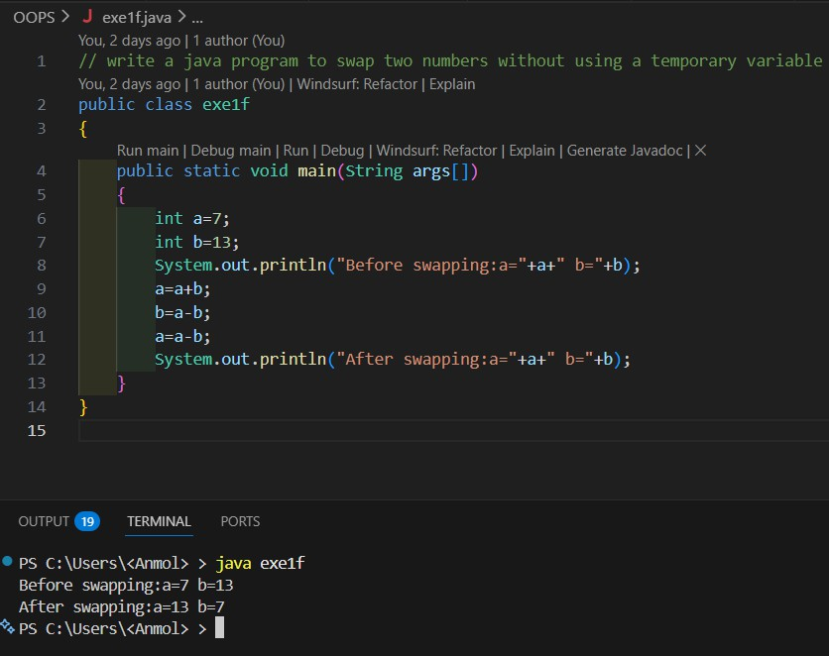
Obseravtion: creates a class named exe1f and swaps two numbers without using a temporary variable and prints the values before and after swapping using main method and int data type variables a and b for the two numbers.

EX 1G
Write a Java program to check whether a number is even or odd.

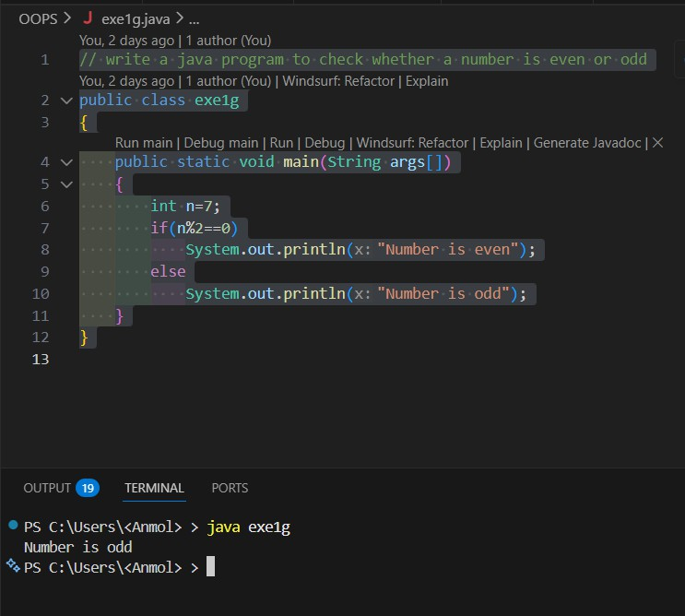
Observation: creates a class named exe1g and checks whether a number is even or odd using main method and int data type variable n for the number using modulus operator and if-else statement to determine evenness or oddness.

EX 1H
Write a Java program to find the largest of two numbers.

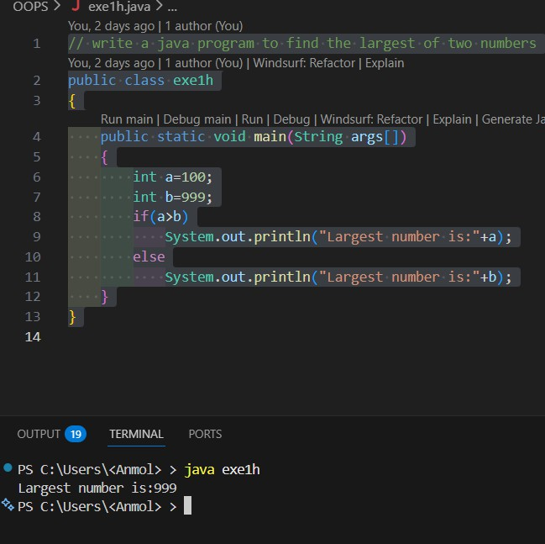
Obseravtion:
creates a class named exe1h and finds the largest of two numbers using main method and int data type variables a and b for the two numbers using if-else statement to compare the two numbers.

EX 1I
Write a Java program to find the largest of three numbers.

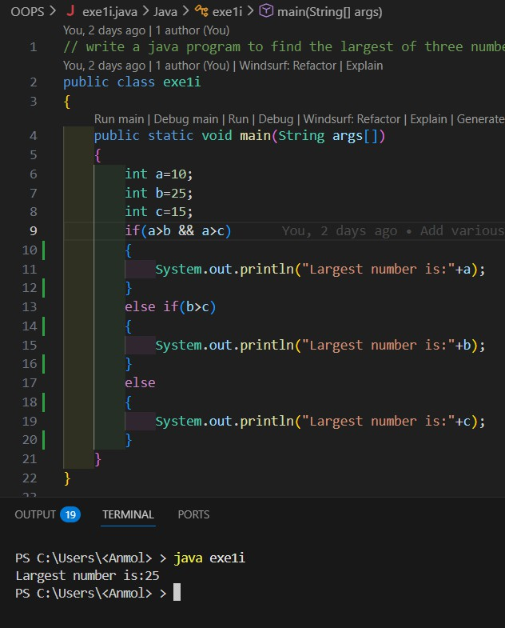
Observation:
creates a class named exe1i and finds the largest of three numbers using main method and int data type variables a, b and c for the three numbers using if-else-if statement to compare the three numbers.

EX 1J
Write a Java program to check whether a given year is a leap year.

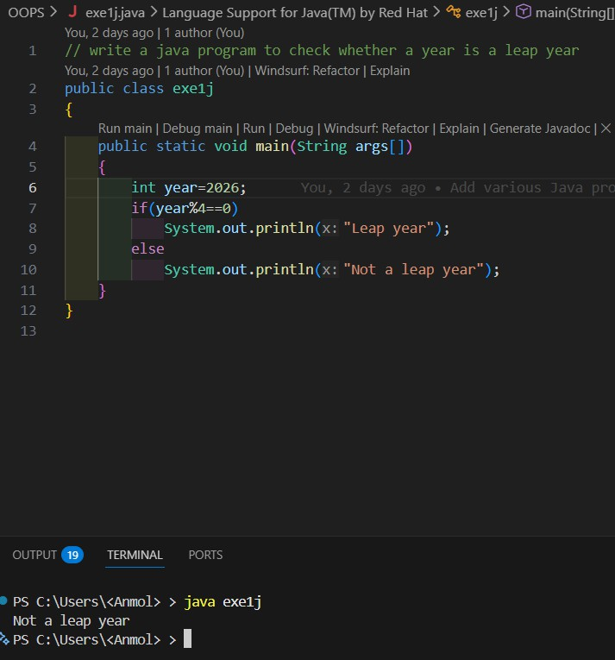
Observation:
creates a class named exe1j and checks whether a year is a leap year using main method and int data type variable year for the year using modulus operator and if-else statement to determine leap year status and print the result.

EX 1K
Write a Java program to check whether a character is a vowel or consonant.

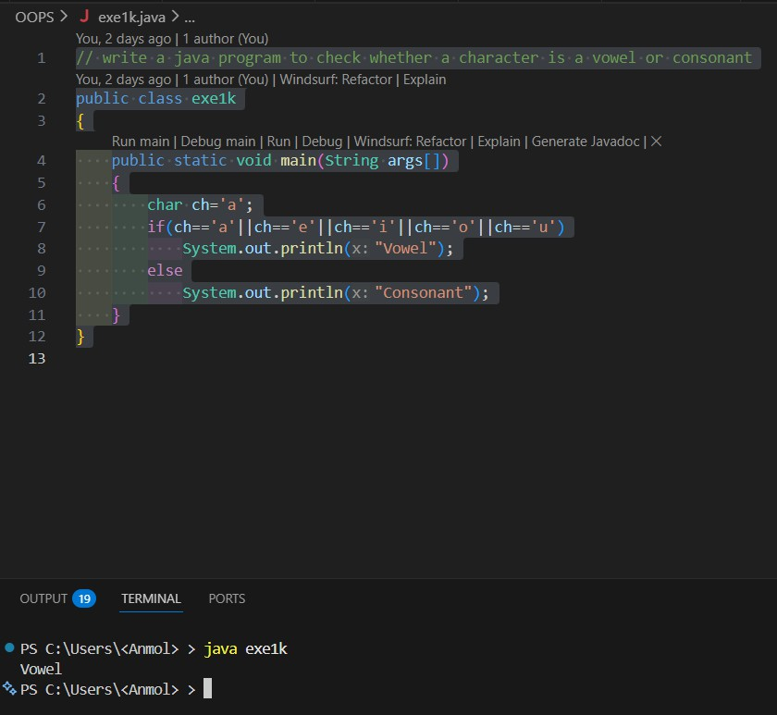
Observation: creates a class named exe1k and checks whether a character is a vowel or consonant using main method and char data type variable ch for the character using if-else statement to determine vowel or consonant status and print the result.

EX 1L
Write a Java program to perform addition, subtraction, multiplication and division.

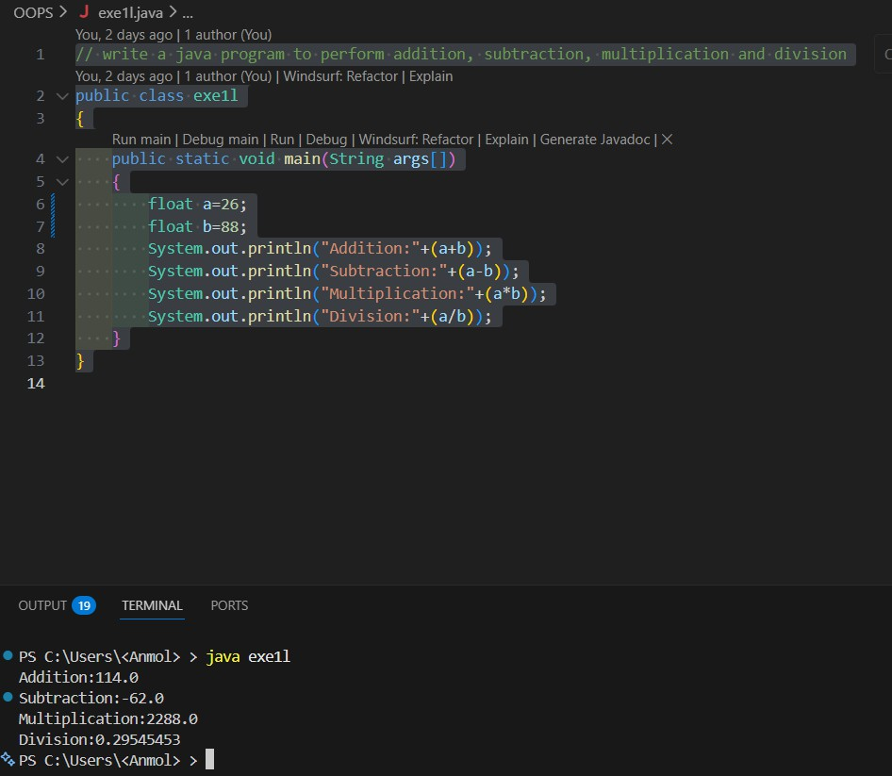

Observation: creates a class named exe1l and performs addition, subtraction, multiplication and division using main method and float data type variables a and b for the two numbers and prints the results of the operations.

